Interpretation: Similar trends shown across soil types. Units on y to be worked out still, but comparison should still hold. Trends show that in order of carbon respired: DASE, AD, C-CBP, CS ie. the materials the show the most C retention in increasing order are: CS, C-CBP, AD, DASE. DASE being the most retentive.

|  |  |  |
| --- | --- | --- |
|  | **C RETENTION IN TREATMENTS (SOIL + RESIDUE) [g]** | |
|  | **PALOUSE** | **VERSHIRE** |
| **CS** | 2.55% | 3.35% |
| **AD** | 3.99% | 3.80% |
| **CCBP** | 2.56% | 3.48% |
| **DASE** | 3.47% | 3.74% |

Interpretation: Trends are the same across soil types.. If statistical analysis applied on data, may show that differences are reconcilable. In order of increasing C retention for both: CS, C-CBP, DASE, AD.

Interpretation: Sampling schedule appears effective. First three months definitely the most important. Precision appears relatively high.

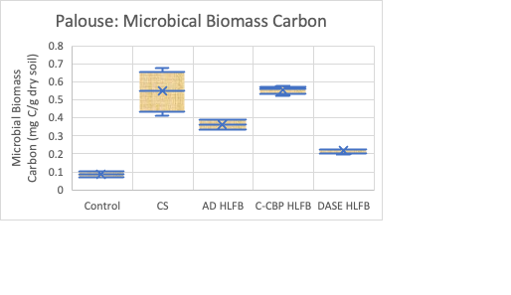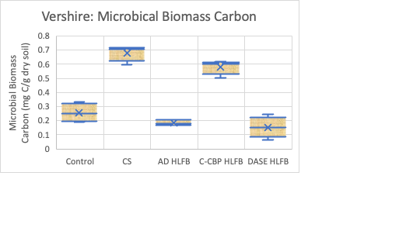

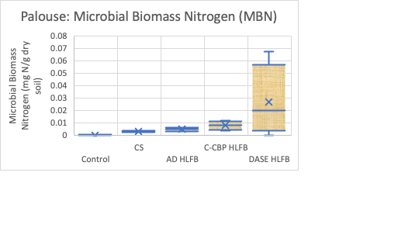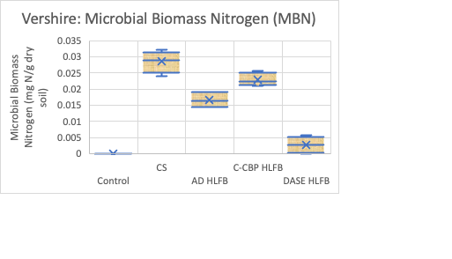

Interpretation: MBC is relatively comparable between soil types. Trends of Palouse show MBC increasing from control, DASE, AD, C-CBP~CS; Trends of Vershire show MBC increasing from DASE, AD, control, C-CBP, CS. MBN is not similar between soil types nor precise. Different magnitudes of values and trends are entirely different. Values possible too small to detect.

Interpretation: MBC values may be too variable if not carefully rounded especially for Vershire with consistently larger dataspread.